20241013 Hebrews 4 – Our High Priest

This morning, I am using the ESV instead of my usual NKJV. For some reason this passage seems a bit easier to understand in the ESV. So, open your Bibles with me to Hebrews chapter 4 and let’s read. The writer will explain to his Jewish-Christian audience several ways that faithful believers enter into God’s “rest.” There seem to be two parallels going on: (1) entering the Promised Land connotes the rest we enjoy when we enjoy the blessings of God if we choose to walk in belief instead of unbelief, and (2) partaking of the Sabbath ritual connoted a more distant “rest” that believers enjoy not in a particular day of the week, but in Jesus Himself.

¹Therefore, while the promise of entering his rest still stands, let us fear lest any of you should seem to have failed to reach it. ² For good news came to us just as to them, but the message they heard did not benefit them, because they were not united by faith with those who listened. ³ For we who have believed enter that rest, as he has said,

“As I swore in my wrath,
‘They shall not enter my rest,’”

although his works were finished from the foundation of the world. ⁴ For he has somewhere spoken of the seventh day in this way: “And God rested on the seventh day from all his works.” ⁵ And again in this passage he said,

“They shall not enter my rest.” (Hebrews 4:1-5, ESV).

Some say that the Old Testament is irrelevant to the Christian life, but I want to remind everyone what Paul said. “⁴ For whatever was written in former days was written for our instruction, that through endurance and through the encouragement of the Scriptures we might have hope.” (Romans 15:4, ESV). So, everything that we’re studying this morning is given for our instruction, and it can encourage us through whatever we might have to endure, giving us great hope along the way.

V.1 The writer continues his warning saying that this promise of rest from God continues, and we should be on our guard against unbelief lest we fail to reach that rest. So, what exactly is the “rest of God?” How do we know when we’re in His “rest?”

Almost every week, I end the service with the Aaronic Blessing. It ends with a blessing that the peace/shalom of the Lord might be on us. Shalom is a big deal. We don’t really have any way to translate that into English exactly. But a good way to think of Shalom is entering into and abiding in the “peaceful” “rest” of God. I’m talking about being at total peace with our circumstances. If we are not on our guard, MANY THINGS THAT CAN STEAL OUR REST.

As an example, at present many believers are sick with worry over the upcoming presidential election. There is so much confusion, societal chaos, and tension in the air right now. The wholesale anxiety is so high you can almost feel it. People on all sides are freaking out and wearing themselves thin, worrying over this election. Obsession with the upcoming election can easily take way our “rest.” My first sermon to this congregation in 2016 was on this same subject. I told you something then, and I’ll tell it to you now, “regardless of who is president of the United States, Jesus is still King.” We can rest in that truth. But unfortunately, our worries are not confined to the presidential election. If we are not on our guard, we can easily become robbed of our rest on all sides. An in the end, the real source of our lack of rest is unbelief. We forget that God has a greater plan than what we think should happen. Our faith gives way to fear with just the slightest inattention to having in the end our total confidence and faith in God Himself. No political outcome or lasting circumstances can give us real peace.

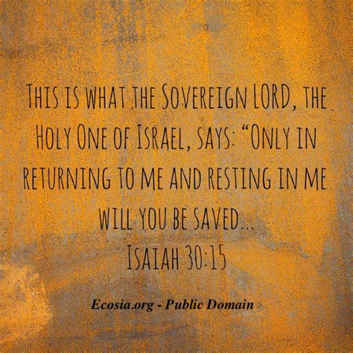
Vv. 2-5 “Promised Land Rest” is the first kind of rest the writer discusses. We talked about this some last week. It is the rest we experience when we trust and believe the promises of God and we enjoy a mental attitude we might call the “Faith-Rest” experience. When the Jews left Egypt they quickly began to doubt God and His servant Moses. Their faith gave way to fear, and their lack of belief stretched the 13-day trip from Egypt to the Promised Land into a 40-year nightmare. They sat in fear for 38 of those years in Kadesh-Barnea. This is considered by some as the greatest failure of the Jewish people.

When spies gave negative reports about the insurmountable conditions in the Promised Land, the the Israelites gave up before they ever started. The spies were focused on the fortifications and walls of the cities that they found. They were looking at problems instead of the possibilities. Their unbelief caused them to doubt the promises of God. Only Joshua and Caleb believed that God would do what He said He would do. Let me be clear, their disbelief did not remove their status as God’s chosen people, but it robbed them of the blessings and rest they were promised in the Promised Land. These verses are all about “resting in God.” So why is the writer bringing up this example of the Children of Israel in the desert? It is a picture of what we ourselves lose out on when we fall into unbelief. King David summarized the story in Psalm 95.

Today, if only you would hear his voice,
⁸ “Do not harden your hearts as you did at Meribah,
as you did that day at Massah in the wilderness,
⁹ where your ancestors tested me;
they tried me, though they had seen what I did.
¹⁰ For forty years I was angry with that generation;
I said, ‘They are a people whose hearts go astray,
and they have not known my ways.’
¹¹ So I declared on oath in my anger,
‘They shall never enter my rest.’” (Psalm 95:7b-11, NIV).

Verse eleven is a sad statement. Because of their unbelief God declared that none of them would enter into the rest of the Promised Land. God never intended that Israel would be stuck in Kadesh-Barnea for 38 years. If they had walked by faith instead of by sight, they would have been enjoying the rest of the Promised Land on the 14th day after leaving Egypt.

So, what is the link between the “Promised Land” and “Entering into His Rest?” He is talking about walking into and walking in the promises of God. Because of their fear, they were not able to enjoy the blessings and the promises that God had intended for them. It was a place where they could’ve arrived and no longer worried about a thing. God promised them total victory and provision if they would take the land as instructed. Instead, they were stuck in a place where they were captives of their own fear and unbelief. Numbers 13:33 tells us EXACTLY where they were mentally. “ ³³ And there we saw the Nephilim (the sons of Anak, who come from the Nephilim), and we seemed to ourselves like grasshoppers, and so we seemed to them.” (Numbers 13:33, ESV).

We, Christians right now in the present, are to learn from what happened back there in the desert. Paul’s letter to the Corinthian church warns us to not fall into these same traps. “¹¹ Now these things happened to them as an example, but they were written down for our instruction, on whom the end of the ages has come. (1 Corinthians 10:11, ESV).

⁶ Since therefore it remains for some to enter it, and those who formerly received the good news failed to enter because of disobedience, ⁷ again he appoints a certain day, “Today,” saying through David so long afterward, in the words already quoted,

“Today, if you hear his voice,
do not harden your hearts.”

⁸ For if Joshua had given them rest, God would not have spoken of another day later on. ⁹ So then, there remains a Sabbath rest for the people of God, ¹⁰ for whoever has entered God's rest has also rested from his works as God did from his.
¹¹ Let us therefore strive to enter that rest, so that no one may fall by the same sort of disobedience. (Hebrews 4:6-11, ESV).

Vv. 6-7 He continues to warn the readers not to have hardened hearts. If you look carefully, you can see that he transitions to talking about a different kind of rest in these next few verses.

V. 8 The fact is that even when Joshua took the Israelites into the Promised Land, there was only a partial fulfillment of the rest that they were promised. There was another rest spoken of that was yet to come. So, what rest could that possibly be? It’s the rest we enoy when we finally come into that rest found only in Jesus.

V. 9-13 ⁹ So then, there remains a Sabbath rest for the people of God, (Hebrews 4:9, ESV). God rested from His creative work on the Sabbath, and we can rest when we trust and rely on Jesus. He is our rest. He saved us, not because of works done by us in righteousness, but according to his own mercy, by the washing of regeneration and renewal of the Holy Spirit. (Titus 3:5, ESV). Just as Israel celebrated a Sabbath each week, we celebrate a continual Sabbath when we rest in Jesus. He is our rest. He is our peace. He is our Shalom. Paul told us in the Book of Romans (Romans 14:5-6) that the specific day of the week is no longer important. We achieve or “Sabbath Rest” when Jesus is the centerpiece of our faith.

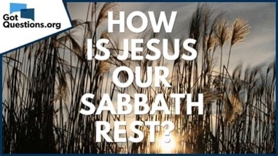
The writer continues the theme so that these believing Jews would understand that IT ALL POINTED TO JESUS. The Sabbath was given in the Old Testament to help us understand how we are saved. Jesus is our rest, so we don’t need to keep the Sabbath to be saved. It is RESTING IN THE FINISHED WORK OF JESUS THAT WE FIND OUR SALVATION. The Sabbath was a picture of resting in Him. Entering the Promised Land was a picture of enjoying the rest of experiencing all of His benefits.

Some feel this means that Sunday is their special day. That’s okay with me. Many of you all know that I take a Sabbath sort of rest Sunday after naptime until Monday around noon. That’s just the time I take each week to let God recharge my spiritual batteries. It works for me, but I don’t put that off on anyone else. The bottom line is that the true Sabbath rest is in Jesus.

GOD CAN TELL IF THERE IS ANY UNBELIEF IN OUR HEARTS

The writer now turns to one of my favorite verses in the Bible. This speaks to the absolute superiority of not only Jesus as the Word, but the written Word of God as well.

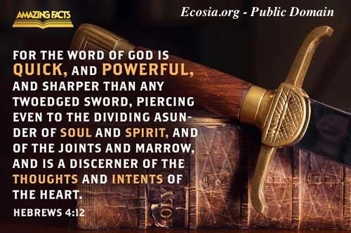
¹² For the word of God is living and active, sharper than any two-edged sword, piercing to the division of soul and of spirit, of joints and of marrow, and discerning the thoughts and intentions of the heart. ¹³ And no creature is hidden from his sight, but all are naked and exposed to the eyes of him to whom we must give account.
Jesus the Great High Priest (Hebrews 4:12-13, ESV).

I love verse 12, but it is important to understand how it fits into this discussion of unbelief. The writer now presents the importance of God’s Word in protecting the believer from unbelief. These Christian Jews who were in peril were most likely experiencing all kinds of emotions to justify walking away from Jesus. This reminds them that God’s Word can see right into us exposing our motives. The reality is that God sees us as we are. Sometimes (I would say often.) we are not even able to recognize our own motives concerning what we think, say, and do. We may even think we’re moved by God to think, say, or do something, but the reality is that God isn’t in it at all. We hear this twice in the book of Proverbs.

There is a way that seems right to a man, but its end is the way to death. (Proverbs 14:12 and Proverbs 16:25, ESV).

This reminds us that just because we think we’re spiritually justified in thinking a certain way or doing a certain something, it doesn’t mean that it passes the “smell test” with God! God sees it all. Some of you will notice that I am VERY RELUCTANT to ever say, “God told me this, or God told me that.” Because if I am wrong, I am guilty of blaspheming God. Instead I’ll say something like, “I feel moved to do such and such.” Or, “I feel moved to say such and such.” God knows the intentions of my heart even when I can’t decipher or discern them.

The writer presents five solid truths concerning the Word of God.

- The Word [Logos- Jesus or the Inspired Word of God] of God is ALIVE. The Spirit of God turns a dead sinner into a new living creation. ¹⁷ Therefore, if anyone is in Christ, he is a new creation. The old has passed away; behold, the new has come. (2 Corinthians 5:17, ESV).

- The Word of God is Active [ernerges=effective and powerful]. It shows itself with vigorous activity. God’s Word is at work in our hearts. It is DYNAMIC. It will constantly push you. He loves you enough not to leave you where he finds you!

- The Word of God is sharper [tomoteros ] than a sword. The Greek word here is tomoteros, and it implies continual cutting and hacking. This is more than just one slice. God’s Word carves away at the heart of man revealing the true motives behind what we think, say, and do. It doesn’t just cut – IT SEPARATES!

- The Word of God is PIERCING [diiknoumenos]. God’s Word passes through or goes directly through man's heart. It is so penetrative that it gets into the deepest recesses of the human psyche (here described as the soul and the spirit). These are the unseen elements of what make a human being what a human being is. BEWARE, the soul of man can imitate the Spirit of God and it might have nothing to do with the Holy Spirit. This a great weakness of religious movements that rely on a “new word from God” or a “new truth,” or “special revelation.” Avoid those who claim such things.

- Lastly, God’s Word is quick to discern [kritikos – able to judge]. God’s Word is so penetrative that it is able to reveal the thoughts and intents of the heart. It is a CRITIC (one who judges the merits) of the thoughts and intents of the heart. It unveils the junk in our hearts and minds.

Many of you have heard me make the analogy that God’s Word is like an operating system that we can download into our soul through Bible Study, sound teaching, and prayer. As it runs in the background of our soul, it has filters similar to an anti-virus program that exposes renegade thoughts and actions, and it has a mechanism by which to isolate and eliminate the “rogue” thoughts within us. Think of it as something like Norton Antivirus. AND IT NEEDS UPDATES! That means frequent time in the Word! God’s Word is the centerpiece weapon in our arsenal of spiritual weaponry.

³ For though we walk in the flesh, we are not waging war according to the flesh. ⁴ For the weapons of our warfare are not of the flesh but have divine power to destroy strongholds. ⁵ We destroy arguments and every lofty opinion raised against the knowledge of God, and take every thought captive to obey Christ, ⁶ being ready to punish every disobedience, when your obedience is complete. (2 Corinthians 10:3-6, ESV).

V.v. 14- 16 The writer now pens some of the most comforting words in the New Testament.

¹⁴ Since then we have a great high priest who has passed through the heavens, Jesus, the Son of God, let us hold fast our confession. ¹⁵ For we do not have a high priest who is unable to sympathize with our weaknesses, but one who in every respect has been tempted as we are, yet without sin. ¹⁶ Let us then with confidence draw near to the throne of grace, that we may receive mercy and find grace to help in time of need. (Hebrews 4:14-16, ESV).

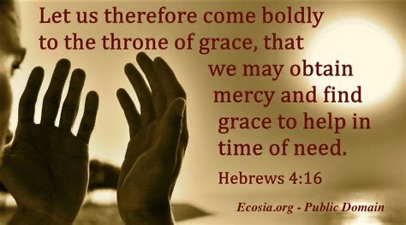
We have the most perfect wonderul High Priest. It is Jesus. Because of Him we are to “hold fast to our confession.” That means DON’T LET GO. STAY THE COURSE. If you find yourself in a sin pattern that even shocks you, these are the words that can soothe your soul. Jesus was tempted in every way that we are tempted, and yet He did not sin. But having passed through the same fires that we pass through, we can approach the throne room of God confidently without our heads hung down. We are promised “mercy and help” in our time of need.

Let us pray.

Union Grove is one of the oldest Baptist communities of faith in the State of Texas dating back to 1844. Pastor Faber McMullen may be reached by email at uniongrove362@gmail.com or by snail mail at: 15301 FM 362, Navasota, Texas 77868. Tel: 936-825-1227 (Edited and proofed by Amanda Neese- Webster, Texas.) All financial gifts to this ministry are tax-deductible as a 501 (c) (3) Corporation.

In the Irish language it is translated as “An Brí.“ This word literally means “the meaning” or “the energy.” That is a much better word than the “word” we use in the English Language. Jesus is the meaning of all and the energy behind all.
https://www.biblestudytools.com/lexicons/greek/nas/tomoteros.html#:~:text=tomotero%C3%9F,implies%20repeated%20blows%2C%20like%20hacking)

