20241117 Hebrews Chapter 9 & 10 Pt 1 – Back to the Garden

We will continue to discuss the writer’s comments on moving from Melchizedek into the ministry of the Tabernacle. Last week we talked about the Old Covenant and the New Covenant. Now the author will discuss the earthly Tabernacle as a reflection of the throne room in heaven. For those who may not know, a tabernacle is just another word for a tent. Back when Moses was on Mount Sinai, God gave him specific instructions on how to build this special tent. In a moment, I’d like to show you a diagram of the floorplan of that Tabernacle so you can understand what it was and how it was used as a place of worship.

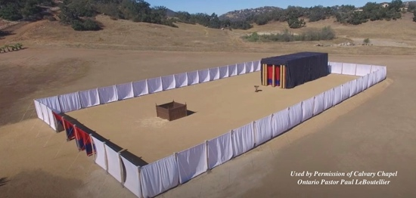Interestingly, before God gave instructions for the building of the Tabernacle, Moses met with God in something merely called the “Tent of Meeting” (see Exodus 33:7-11). Scripture tells us that Moses would go meet with God in that place face to face, and a cloud would descend on the place and all of Israel looked on and worshipped when God would visit. Often Joshua would be there with Moses, and scripture says that sometimes Joshua would stay. Think how amazing that would have been to just “hang out” with God. It reminds us a little bit about Adam and Eve in the Garden of Eden, doesn’t it? There they were face to face with God and Moses was now doing the same thing in the little tent that was the “Tent of Meeting.” After that time, God then gave a whole set of instructions for construction of that special tent which we now call the “Tabernacle.” It can get a little confusing because it was also called “The Tent of Meeting” just like that former small tent had been called. This newly constructed tabernacle had an outer court measured 75 Ft X 150 Ft. That outer court would be just about the same size as our sanctuary here at the Grove. The enclosed part which contained the Holy of Holies was much smaller than that. The whole covered part was about 15 FT X 45 FT, and the Holy of Holies was 15 FT X 15 FT. Let’s begin in Chapter 9 with a description.

**The Earthly Holy Place**

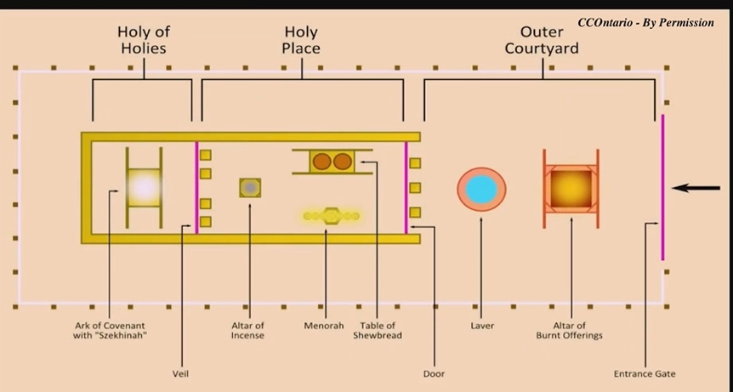***9 Now even the first covenant had regulations for worship and an earthly place of holiness. 2For a tent*** [15 x 45 for both rooms] ***was prepared, the first section*** [30X15)***, in which were the lampstand and the table and the bread of the Presence.n It is called the Holy Place. 3Behind the second curtain was a second sectioncalled the Most Holy Place*** [Holy of Holies 15X15] ***, 4having the golden altar of incense*** [taken in by the priest not there always] ***and the ark of the covenant covered on all sides with gold, in which was a golden urn holding the manna*** [how God fed them in the wilderness]***, and Aaron's staff that budded, and the tablets of the covenant*** [two tablets of the 10 Commandments]***. 5Above it were the cherubim*** [mighty angels that attend the throne of God] ***of glory overshadowing the mercy seat. Of these things we cannot now speak in detail.*** [The author is just going to use these things as reference to his conversation.]

***6These preparations having thus been made, the priests go regularly into the first section, performing their ritual duties,***[He went in and out of there daily – menorah, incense, bread etc] ***7but into the second only the high priest goes, and he but once a year*** [on Yom Kippur]***, and not without taking blood, which he offers for himself and for the unintentional sins of the people.***[The High Priest went in only once a year and he sprinkled blood on the Mercy Seat – he went in twice: once for himself and then for the nation] ***8By this the Holy Spirit indicates that the way into the holy places is not yet opened*** [The way is closed you can’t go into His presence. Only the priest could do so.] ***as long as the first section is still standing 9(which is symbolic for the present age).***[This is symbolic ‘*Gk.parable’* of the present age.]***According to this arrangement, gifts and sacrifices are offered that cannot perfect the conscience of the worshiper, 10but deal only with food and drink and various washings, regulations for the body imposed until the time of reformation.*** [These things ONLY made the worshipper ritually clean, but didn’t COMPLETELY clean them. It was a provision for the external not the internal. I think of it as cleaning only the outside of a broken down dirty car. The interior is cleaned differently as the repairs that are made have nothing to do with that outside washing.] ***(Hebrews 9:1-10, ESV with author’s notes in brackets).***

Scripture also tells us that the Children of Israel had to keep a distance from the Tabernacle. They couldn’t get physically close to where the spiritual action was taking place. They had to keep a distance of about a half of a mile (Joshua 3:4). This distance would never come to an end until Jesus yielded His Spirit on the cross and the veil of the curtain in the Temple was torn from top to bottom.

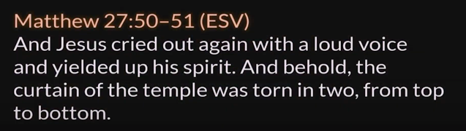WE NO LONGER HAVE TO KEEP A DISTANCE FROM GOD. JESUS NOW CLEANSES US WHERE WE CAN “GO IN” TO WORSHIP. THE CURTAIN OF THE TEMPLE WAS TORN IN TWO.This symbolized that the barrier between God and man had been torn asunder. What an incredible privilege it is that we have direct access to God Almighty.

This is why we so often pray what we pray: ***Let us then with confidence draw near to the throne of grace, that we may receive mercy and find grace to help in time of need. (Hebrews 4:16 ESV).***

**THIS WAS NEW TERRITORY FOR THESE CHRISTIAN JEWS IN JUDEA. They couldn’t imagine such intimacy, and the writer is repeating again and again the manner in which Jesus provides such intimacy.**

**Redemption Through the Blood of Christ**

***11But when Christ appeared as a high priest of the good things that have come, then through the greater and more perfect tent (not made with hands, that is, not of this creation) 12he entered once for all*** [It’s over and done with.]  ***into the holy places, not by means of the blood of goats and calves but by means of his own blood, thus securing an eternal redemption.*** [Jesus paid it all. It’s over.]***13For if the blood of goats and bulls, and the sprinkling of defiled persons with the ashes of a heifer, sanctifyfor the purification of the flesh, 14how much more will the blood of Christ, who through the eternal Spirit offered himself without blemish to God, purify ourconscience from dead works to serve the living God.*** [Jesus’ sacrifice was the real thing, cleansing our consciences. It was an internal cleansing and not just an external cleansing].

***15Therefore he is the mediator of a new covenant, so that those who are called may receive the promised eternal inheritance, since a death has occurred that redeems them from the transgressions committed under the first covenant.*** [What this is saying is that it emphasizes the superiority of what Jesus has done for us. It’s the death of Jesus Who died for us on the cross and redeemed us from our transgressions. Jesus died and paid for ALL SINS including those committed under the first covenant. That means He died and paid for the all sins of the whole world that have ever been committed. He died for the rebellion and the “sin DNA” which each of us carries as members of the human race.]

***16For where a will is involved, the death of the one who made it must be established.*** [One of the things about doing probate law is to realize you can’t really move forward without a death certificate. The benefits that are to be given in a will can’t be given under the provisions of the will unless the testator is dead. I always use the information on the death certificate to fill out the forms necessary to probate the estate.]***17For a will takes effect only at death, since it is not in force as long as the one who made it is alive.*** [So the new “testament” (another word for a Will or Covenant) didn’t go into effect while Jesus, the testator, was still alive.] ***18Therefore not even the first covenant was inaugurated without blood. 19For when every commandment of the law had been declared by Moses to all the people, he took the blood of calves and goats, with water and scarlet wool and hyssop, and sprinkled both the book itself and all the people, 20saying, “This is the blood of the covenant that God commanded for you.” 21And in the same way he sprinkled with the blood both the tent and all the vessels used in worship. 22Indeed, under the law almost everything is purified with blood, and without the shedding of blood there is no forgiveness of sins. (Hebrews 9:11-22, ESV with author’s notes in brackets).***

That first covenant was sealed with blood. In the Jewish mind, blood was sacred as it was the substance that held life itself (Leviticus 17:11). There is a principle stated here . For sin to be forgiven, the shedding of blood is necessary. This is why God prohibited the Israelites from eating blood. It was considered sacred. Under the Old Testament/Covenant, everything had to be cleansed with blood. This is similar to the language used by Jesus at the Last Supper: *"for this is My blood of the new covenant, which is shed for many for the remission of sins." (Matthew 26:28 NKJV])*

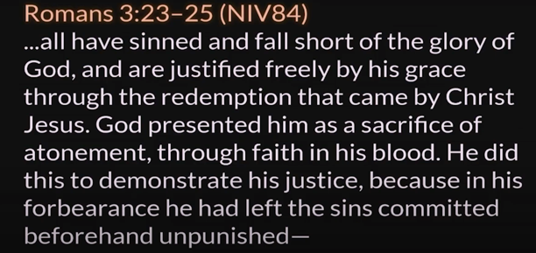As a lawyer, I must add that this point of the “shedding of blood” is one of the strangest and seemingly arbitrary things about our faith. It is strange and difficult for me as I find the logic to be circular. I’ve asked myself, “Why would God have to come as a human to be killed by other humans to satisfy Himself?” If I think it through logically, the “shedding of blood” has at least three main effects on the participant (or the watching or giving of an animal): **(1)** It accentuates the seriousness of sin itself. It’s a horrific thing to see that something has to die for what I’ve done. **(2)** It also shows mankind the principle of a severe judgment for a wrong done in that there are real and serious consequences to wrongdoing. Hence, sin is costly. **(3)** It demonstrates the mercy of God in that He was willing to accept a substitute as a sacrifice for one’s wrongdoing. Some other life pays the price for my errancy. It still is one of the hardest concepts for me as a believer, but this is one of those things that falls into the category of the “mysteries of God.” Let’s continue.

***23Thus it was necessary for the copies of the heavenly things to be purified with these rites, but the heavenly things themselves with better sacrifices than these.*** [So, these physical rites were laid out as a visual representation or a “copy” of what was to come.] ***24For Christ has entered, not into holy places made with hands, which are copies of the true things, but into heaven itself, now to appear in the presence of God on our behalf.*** [So, Jesus has entered into something like the Holy of Holies in heaven.]***25Nor was it to offer himself repeatedly, as the high priest enters the holy places every year with blood not his own,***[The high priest had to do this annually and repeatedly.] ***26for then he would have had to suffer repeatedly since the foundation of the world. But as it is, he has appeared once for all at the end of the ages to put away sin by the sacrifice of himself. 27And just as it is appointed for man to die once, and after that comes judgment, 28so Christ, having been offered once to bear the sins of many, will appear a second time, not to deal with sin but to save those who are eagerly waiting for him. (Hebrews 9:23-28, ESV with author’s notes in brackets).***

This accentuates that the sacrifice for our sins is completed and done. When Jesus comes back it will not be to deal with sin. That’s done and finished. John tells us that His last word on the cross was ***“tetelestai.”*** The Greek word tetelestai (τετέλεσται) is translated to "it is finished" in English. In that last day when Jesus returns, He will come to present salvation to all of us who have believed in Him. We are here eagerly awaiting an incredible future to come. Life on earth has its problems. There is still sickness and disease, but that is coming to an end. We will receive all of that in its fullness when He comes back for us. I’m sure ready. How about you?

You might note as well that this refutes the idea of reincarnation. God is telling us here that all humans will just die once. We don’t come back over and over to live through all of this again.

***10 For since the law has but a shadow*** [The Mosaic Law was a fuzzy shadow.]***of the good things to come instead of the true form of these realities, it can never, by the same sacrifices that are continually offered every year, make perfect those who draw near.*** [It wasn’t possible to get rid of the sin once and for all because they had to do it every year.] ***2Otherwise, would they not have ceased to be offered, since the worshipers, having once been cleansed, would no longer have any consciousness of sins? 3But in these sacrifices there is a reminder of sins every year. 4For it is impossible for the blood of bulls and goats to take away sins.*** [The blood of bulls and goats were just a picture of a spiritual reality. We, too, don’t have to keep beating up on ourselves for our past and for our past sins. Many of us nourish or hold on to our hurts, habits, and hangups, and we let the Devil accuse us with them. Likewise, our feelings sometimes tell us to condemn ourselves but that, in itself, is walking in sin. “Jesus paid it all. All to Him I owe. Sin had left a crimson stain. He washed it white as snow.” When we go back and ask for forgiveness (1 John 1:9), we’re not asking God to pay for those sins that were already paid for. We’re making sure there’s nothing between us and God relationally. That is the part that takes care of our human consciences. I know I’m going to heaven but it’s me telling God that I don’t want anything to affect my relationship with Him. It’s not about getting saved again. It is about me reminding myself that He paid it all and that I want to walk in that relationship with a clean conscience.]

***5Consequently, when Christcame into the world, he said,***

***“Sacrifices and offerings you have not desired,*** [Psalm 40:6] ***but a body have you prepared for me;*** [Messiah is speaking. He had to be a human.] ***6in burnt offerings and sin offerings you have taken no pleasure.*** [They can’t do the job.] ***7Then I said, ‘Behold, I have come to do your will, O God,  
    as it is written of me in the scroll of the book.’”*** [This is Jesus speaking of Himself. The author is quoting out of the Septuagint. Jesus is declaring His willingness to be the sacrifice of all of mankind. Jesus is saying, “All of the scrolls and prophets spoke of Me.”]

***8When he said above, “You have neither desired nor taken pleasure in sacrifices and offerings and burnt offerings and sin offerings” (these are offered according to the law), 9then he added, “Behold, I have come to do your will.” He does away with the first in order to establish the second. 10And by that will we have been sanctified through the offering of the body of Jesus Christ once for all. 11And every priest stands daily at his service, offering repeatedly the same sacrifices, which can never take away sins. 12But when Christhad offered for all time a single sacrifice for sins, he sat down at the right hand of God, 13waiting from that time until his enemies should be made a footstool for his feet. 14For by a single offering he has perfected for all time those who are being sanctified.***

***15And the Holy Spirit also bears witness to us; for after saying, 16“This is the covenant that I will make with them after those days, declares the Lord: I will put my laws on their hearts,  
and write them on their minds,” 17then he adds, “I will remember their sins and their lawless deeds no more.” 18Where there is forgiveness of these, there is no longer any offering for sin. (Hebrews 10:1-18, ESV with author’s notes in brackets).***

I started out mentioning that God and man had sweet communion together in the Garden of Eden. Rabbis throughout the ages have noted that the design of the Tabernacle and the Temple were an attempt to “get back to the Garden”. As a matter of fact, much of the artistry adorning the metal vessels, the tapistry and the funishings of the Tabernacle and Temple are thematically reminiscent of the Garden of Eden. Man longs for a life free of the curse of sin. Mankind longs to be redeemed and to once again walk hand-in-hand with Almighty God. The beauty is that God offers us a piece of that now while we’re here on earth. When the veil of the Temple was torn asunder, the message proclaimed was that God and mankind can be reconciled.

That physical picture of God’s redemptive plan was seen in the construct of the Tabernacle. But Jesus is the REAL DEAL. This is telling us that it’s done and done. When we are covered in the blood of Jesus, God “remembers our sins no more.” It was only Jesus Who was perfect and sinless Who could be the noble sacrifice for you and me. And because of His work on the cross, there are no longer any offerings required for our wrongdoing.

So, what is the practical take-away in this scripture today? I think it is to truly get into our minds that our sins really were paid for once and for all on the cross. We are not meant to live lives caught up in guilt and shame over what we have done wrong. The love of God draws us to Him. Guilt and shame will only drive you away from God. I do not teach and preach “sin management.” Rather, I teach that God’s grace covers all our wrongdoing. I am in no way preaching a grace-filled life full of sin and bad behavior. I am preaching the concept that your works didn’t save you, and that they won’t keep you saved. It’s all about His grace. You are to walk in holiness because that is walking in a manner worthy of your calling.

He was the Perfect Lamb of God. HE IS the perfect lamb of God. He took upon Himself the sins of the whole world. Jesus paid it all. Give Him praise and glory.

Let us pray.

Union Grove is one of the oldest Baptist communities of faith in the State of Texas dating back to 1844. Pastor Faber McMullen may be reached by email at uniongrove362@gmail.com or by snail mail at: 15301 FM 362, Navasota, Texas 77868. Tel: 936-825-1227 (Edited and proofed by Amanda Neese- Webster, Texas.) All financial gifts to this ministry are tax-deductible as a 501 (c) (3) Corporation.